Programming 1 (Web-based Programming)

Ms. Eng

MCNDHS

Weekly Summative Assessment

|  |
| --- |
| Name: |
| Period: |

**OPEN NOTEBOOK (ONLY YOUR NOTES PLEASE)**

**Part 1 (Multiple Choice)**

1. What does the <body></body> element tag affect?
2. The visible content on a browser.
3. The images on a webpage.
4. The visible content on your desktop.
5. Your health.
6. What category does the <h1></h1>..<h6></h6> element belong to?
7. Hyphens
8. Semantics
9. Structural
10. Frameworks
11. Which of the following pairs do not require a closing tag?
12. <abbr title=” “>
13. <sup><sub>
14. <b><h1>
15. <br><hr>
16. Which of the following is the correct order of sizing from smallest to largest?
17. <h1><h2><h3><h4><h5><h6>
18. <h6><h5><h4><h3><h2><h1>
19. <h>1<h>2<h>3<h>4<h>5<h>6
20. <h>6<h>5<h>4<h>3<h>2<h>1
21. How do I code the MSG chemical compound: C5H8NO4Na

1. C5H8NO4Na
2. <sup>C5H8NO4Na</sup>
3. C<sup>5H<sup>8NO<sup>4Na
4. C<sup>5</sup>H<sup>8</sup>NO<sup>4</sup>Na

Macintosh HD:Users:Skyboxx:Desktop:Screen Shot 2015-10-02 at 1.18.07 PM.png

1. Where is the correct location of the following code:
2. I’m<sub>tiny</sub>
3. I’m<sup>tiny</sup>
4. I’m<sub></sup>tiny
5. I’mtiny<sub>
6. Macintosh HD:Users:Skyboxx:Desktop:Screen Shot 2015-10-02 at 1.30.07 PM.png
7. Which tag would code the following effect:
8. <ins></ins>
9. <del></del>
10. <abbr title=” “>
11. <br>
12. Why doesn’t the <br> tag require a closing tag?
13. It doesn’t affect text.
14. It is not HTML.
15. It needs an opening tag.
16. You are it.
17. What is the role of <hr>?
18. It creates a heading.
19. It creates a break.
20. To close a tab.
21. Microsoft word 2000.
22. Which of the following is the correct formatting of a tag?
23. </i> </i>
24. <i></i>
25. (i)(/i)
26. (/i)(/i)
27. What is a repository?
28. Your project folder.
29. An access keylock.
30. A collection of isolated HTML files.
31. A selection of files for your website.

**Part 2: Use the following code to answer the problems:**

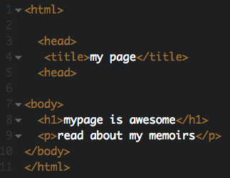

Scenario:

You have written the skeletal template of your webpage with the title, and some content within the body. However, when you tried previewing your site, the following appears:

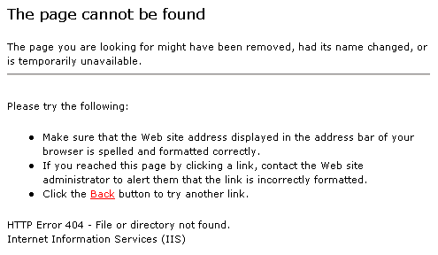

This shows up.

Question 1:

What may be causing this issue, and what would the solution be?

Question 2:

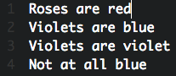Scenario: A student was trying to write a poem to their crush by using html. Although the poem is spaced correctly on the coding side, it appears un-spaced on the client side.

Macintosh HD:Users:Skyboxx:Desktop:Screen Shot 2015-10-02 at 2.20.50 PM.pngCoding side: Client side:

How can this student fix this issue?

Question 3:

Scenario:

Macintosh HD:Users:Skyboxx:Desktop:Screen Shot 2015-10-02 at 2.26.28 PM.pngMacintosh HD:Users:Skyboxx:Desktop:Screen Shot 2015-10-02 at 2.26.08 PM.pngA student was trying to type in a chemical compound for their chemistry class, but ended up with the following:

Macintosh HD:Users:Skyboxx:Desktop:Screen Shot 2015-10-02 at 2.27.01 PM.pngThey want to achieve this:

What is the correct way to code their text so they can accomplish their desired format?